WELCOME SCREEN



private void jButton1ActionPerformed(java.awt.event.ActionEvent evt) {

// TODO add your handling code here:

this.dispose();

new OS_Login().setVisible(true);

}

Login SCREEN

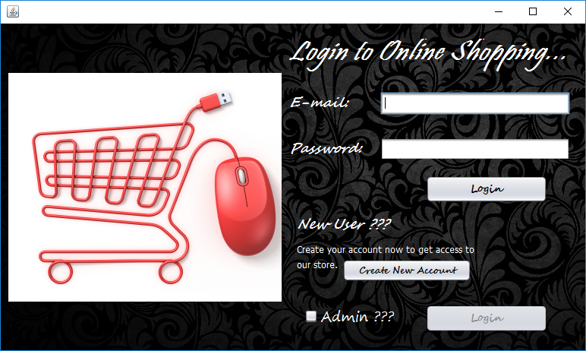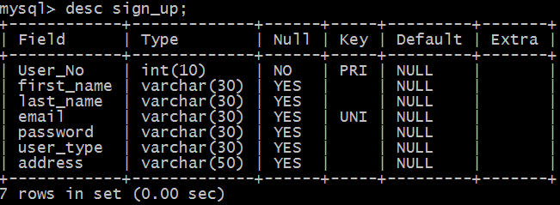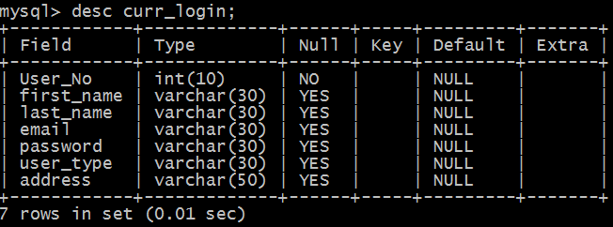

import java.sql.DriverManager;

import java.sql.Connection;

import java.sql.Statement;

import java.sql.ResultSet;

import javax.swing.JOptionPane;

public class OS_Login extends javax.swing.JFrame {

Connection con;

Statement stmt;

String qry;

ResultSet rs;

String DB = "jdbc:mysql://localhost/onlineshopping";

int n=0;

public OS_Login() {

initComponents();

try{

Class.forName("com.mysql.jdbc.Driver");

con=(Connection)DriverManager.getConnection(DB,"root","0000");

stmt=(Statement)con.createStatement();

rs=stmt.executeQuery("select * from sign_up;");

while (rs.last()){

n = rs.getInt("user_no");

rs.close();

stmt.close();

con.close();

}

}

catch (Exception e)

{

System.out.println(e.getMessage());

}

}

private void jButton1ActionPerformed(java.awt.event.ActionEvent evt) {

// TODO add your handling code here:

new OS_Sign_up().setVisible(true);

this.dispose();

}

private void jButton2ActionPerformed(java.awt.event.ActionEvent evt) {

// TODO add your handling code here:

this.dispose();

new OS_Admin_login().setVisible(true);

}

private void jButton3ActionPerformed(java.awt.event.ActionEvent evt) {

// TODO add your handling code here:

String email = jTextField1.getText();

String pass = new String(jPasswordField1.getPassword());

if(email.length()==0)

JOptionPane.showMessageDialog(rootPane,"Please enter E-mail");

else if(pass.length()==0)

JOptionPane.showMessageDialog(rootPane,"Please enter password");

else

{

try{Class.forName("com.mysql.jdbc.Driver");

con = DriverManager.getConnection(DB,"root","0000");

stmt= con.createStatement();

stmt.executeUpdate("delete from curr_login;");

stmt.executeUpdate("delete from bill_items;");

stmt.executeUpdate("insert into curr_login(select * from sign_up where email='"+ email +"');");

rs = stmt.executeQuery("select * from sign_up where email='"+ email +"' ;");

while(rs.next()){

String p = rs.getString("password");

if(p.equals(pass))

{

JOptionPane.showMessageDialog(rootPane,"You Have Signed In Successfully");

this.dispose();

new OS_Navigation_pane().setVisible(true);

}

else {JOptionPane.showConfirmDialog(rootPane,"Username Or Password Is Incorrect !",null,-1,0);}

}

rs.close();

stmt.close();

con.close();

}

catch(Exception e)

{JOptionPane.showMessageDialog(rootPane,e.getMessage());}

}

}

private void jCheckBox1ActionPerformed(java.awt.event.ActionEvent evt) {

// TODO add your handling code here:

if(jCheckBox1.isSelected()==true)

{

jButton2.setEnabled(true);

jTextField1.setEnabled(false);

jPasswordField1.setEnabled(false);

jButton3.setEnabled(false);

}

else

{

jButton2.setEnabled(false);

jTextField1.setEnabled(true);

jPasswordField1.setEnabled(true);

jButton3.setEnabled(true);

}

}

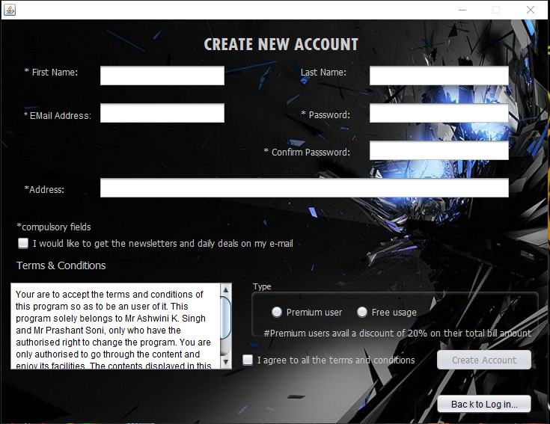

import javax.swing.JOptionPane;

import java.sql.Connection;

import java.sql.DriverManager;

import java.sql.ResultSet;

import java.sql.Statement;

public class OS_Sign_up extends javax.swing.JFrame {

Connection con= null;

Statement stmt = null;

ResultSet rs= null;

String DB = "jdbc:mysql://localhost/onlineshopping";

int n = 0;

public OS_Sign_up() {

initComponents();

try{ Class.forName("com.mysql.jdbc.Driver");

con = DriverManager.getConnection(DB, "root", "0000");

stmt =con.createStatement();

rs=stmt.executeQuery("select * from sign_up;");

while (rs.last()){

n = rs.getInt("user_no");

System.out.println(n);

rs.close();

stmt.close();

con.close();

}

}

catch(Exception e)

{System.out.println(e.getMessage());}

}

private void CreateAccountActionPerformed(java.awt.event.ActionEvent evt) {

// TODO add your handling code here:

try{

n= n+1;

System.out.println(n);

String f_name = jTextField1.getText();

String l_name = jTextField2.getText();

String email = jTextField3.getText();

String addr = jTextField4.getText();

String pass = new String(jPasswordField1.getPassword());

String c_pass = new String(jPasswordField2.getPassword());

String usertype;

if (jRadioButton1.isSelected()){usertype = "Premium";}

else {usertype = "Free";}

if (f_name.length()== 0){ JOptionPane.showMessageDialog(rootPane,"First name field is empty!");}

else{

if (email.length()== 0){ JOptionPane.showMessageDialog(rootPane,"Give the valid E-mail address.");}

else{

if (addr.length()==0){JOptionPane.showMessageDialog(rootPane,"Give the valid Address.");}

else {

if(jRadioButton1.isSelected()== true || jRadioButton2.isSelected()== true){String a= "insert into sign_up values("+ n + ", '"+ f_name + "' , '" + l_name + "' , '"+ email +"' , '"+ pass +"' , '"+ usertype + "','"+ addr +"');";

if(pass.equals(c_pass)){

try{

Class.forName("com.mysql.jdbc.Driver");

con = DriverManager.getConnection("jdbc:mysql://localhost/onlineshopping","root","0000");

stmt = con.createStatement();

int b = stmt.executeUpdate(a);

con.close();

stmt.close();

rs.close();

String show = "You Have Successfully Signed Up With onlineshopping. We Hope That You'll Enjoy Our Service.\n Your Username is :" + email + " \n Your Password is :"+ pass + " \n Your Address is :" + addr + "" ;

JOptionPane.showMessageDialog(rootPane,show);

this.dispose();

new OS_Login().setVisible(true);

}

catch(Exception e)

{JOptionPane.showMessageDialog(rootPane,e.getMessage());}

}

else { JOptionPane.showMessageDialog(rootPane,"Fill password correctly.");}

}

else {JOptionPane.showMessageDialog(rootPane,"Select the User Type");}

}

}

}

jTextField1.setText("");

jTextField2.setText("");

jTextField3.setText("");

jTextField4.setText("");

jCheckBox1.setSelected(false);

jRadioButton2.setSelected(false);

jRadioButton1.setSelected(false);

jPasswordField1.setText("");

jPasswordField2.setText("");

n=n-1;

}

catch (Exception e){

JOptionPane.showMessageDialog(rootPane,e.getMessage());}

}

private void jCheckBox1ActionPerformed(java.awt.event.ActionEvent evt) {

// TODO add your handling code here:

if(jCheckBox1.isSelected()==true)

CreateAccount.setEnabled(true);

else

CreateAccount.setEnabled(false);

}

private void jButton1ActionPerformed(java.awt.event.ActionEvent evt) {

// TODO add your handling code here:

new OS_Login().setVisible(true);

this.dispose();

}

ADMINISTRATOR Login

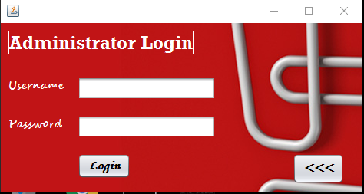

import javax.swing.JOptionPane;

private void jButton1ActionPerformed(java.awt.event.ActionEvent evt) {

// TODO add your handling code here:

this.dispose();

new OS_Login().setVisible(true);

}

private void jButton2ActionPerformed(java.awt.event.ActionEvent evt) {

// TODO add your handling code here:

String uname = jTextField1.getText();

String pass = new String(jPasswordField1.getPassword());

if(uname.length()==0)

JOptionPane.showMessageDialog(rootPane,"Enter Username");

else if(pass.length()==0)

JOptionPane.showMessageDialog(rootPane,"Enter password");

else{

if(uname.equals("vats123") && pass.equals("qwerty"))

{

JOptionPane.showMessageDialog(rootPane,"Login Successful !!!");

new OS_Admin_console().setVisible(true);

this.dispose();

}

else{

JOptionPane.showConfirmDialog(rootPane,"Either username or password is incorrect",null,-1,0);

jPasswordField1.setText("");

}

}

}

ADMIN CONSOLE



private void jMenuItem1ActionPerformed(java.awt.event.ActionEvent evt) {

// TODO add your handling code here:

this.dispose();

new OS_Admin_Prod().setVisible(true);

}

private void jMenuItem2ActionPerformed(java.awt.event.ActionEvent evt) {

// TODO add your handling code here:

this.dispose();

new OS_Admin_Stock().setVisible(true);

}

private void jMenuItem3ActionPerformed(java.awt.event.ActionEvent evt) {

// TODO add your handling code here:

this.dispose();

new OS_Admin_SignUpTable().setVisible(true);

}

private void jMenuItem4ActionPerformed(java.awt.event.ActionEvent evt) {

// TODO add your handling code here:

this.dispose();

new OS_Admin_SignUpForm().setVisible(true);

}

private void jMenuItem5ActionPerformed(java.awt.event.ActionEvent evt) {

// TODO add your handling code here:

this.dispose();

new OS_Admin_StockTable().setVisible(true);

}

private void jMenuItem6ActionPerformed(java.awt.event.ActionEvent evt) {

// TODO add your handling code here:

this.dispose();

new OS_Admin_login().setVisible(true);

}

private void jMenuItem7ActionPerformed(java.awt.event.ActionEvent evt) {

// TODO add your handling code here:

this.dispose();

new OS_Admin_transactions().setVisible(true);

}

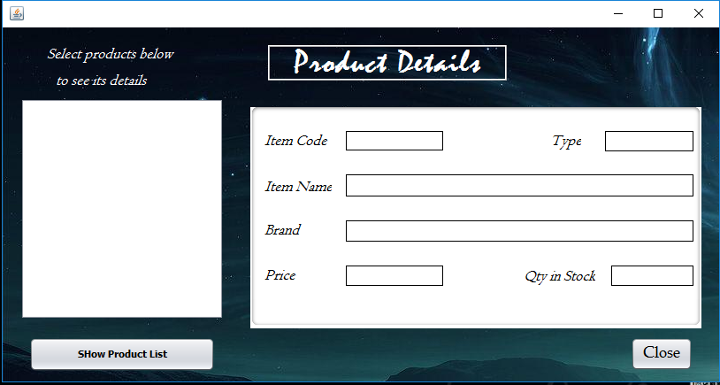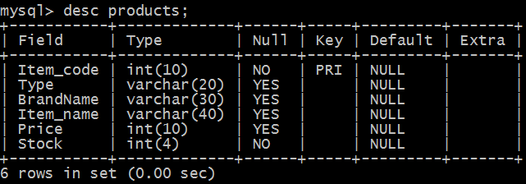

import com.mysql.jdbc.Connection;

import com.mysql.jdbc.Statement;

import java.sql.DriverManager;

import java.sql.ResultSet;

import javax.swing.DefaultListModel;

import javax.swing.JOptionPane;

public class OS_Admin_Prod extends javax.swing.JFrame {

Connection con;

Statement stmt;

ResultSet rs;

String qry="select * from Products;";

public OS_Admin_Prod() {

initComponents();

try

{

Class.forName("java.sql.DriverManager");

con=(Connection)DriverManager.getConnection("jdbc:mysql://localhost:3306/onlineshopping", "root","0000");

stmt = (Statement)con.createStatement(rs.TYPE_FORWARD_ONLY,rs.CONCUR_UPDATABLE);

rs=stmt.executeQuery(qry);

}

catch(Exception e)

{

JOptionPane.showMessageDialog(rootPane,e.getMessage());

}

}

void emptyList(){

DefaultListModel model=(DefaultListModel)listToy.getModel();

while(model.getSize()>0)

model.remove(0); }

private void btnSearchActionPerformed(java.awt.event.ActionEvent evt) {

// TODO add your handling code here:

emptyList();

int count=0;

String query="select Item_name from products;";

DefaultListModel model=(DefaultListModel)listToy.getModel();

try

{

Class.forName("java.sql.DriverManager");

con =(Connection)DriverManager.getConnection("jdbc:mysql://localhost:3306/onlineshopping", "root","0000");

stmt = (Statement) con.createStatement();

rs =stmt.executeQuery(query);

while(rs.next())

{

model.add(count,rs.getString("Item_name"));

count++;

}

}

catch(Exception e)

{

JOptionPane.showMessageDialog(rootPane,e.getMessage());

}

}

private void listToyValueChanged(javax.swing.event.ListSelectionEvent evt) {

// TODO add your handling code here:

String selVal=(String)listToy.getSelectedValue();

String query="select * from Products where Item_name='"+ selVal +"';";

try{

Class.forName("java.sql.Driver");

con=(Connection)DriverManager.getConnection("jdbc:mysql://localhost/onlineshopping","root","0000");

stmt=(Statement)con.createStatement();

rs = stmt.executeQuery(query);

rs.next();

{

lblIcode.setText(""+rs.getInt(1));

lblType.setText(rs.getString(2));

lblBrand.setText(rs.getString(3));

lblIName.setText(rs.getString(4));

lblPrice.setText(""+rs.getFloat(5));

lblStock.setText(""+rs.getInt(6));

}

rs.close();

stmt.close();

con.close();

}

catch(Exception e){

JOptionPane.showMessageDialog(rootPane,e.getMessage());

}

}

private void jButton5ActionPerformed(java.awt.event.ActionEvent evt) {

// TODO add your handling code here:

int n;

n=JOptionPane.showConfirmDialog(rootPane,"Do you want to exit ?");

if(n==0)

{

this.dispose();

new OS_Admin_console().setVisible(true);

}

}

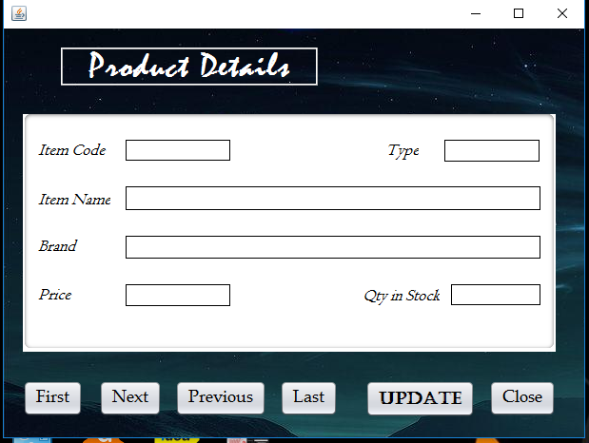

import com.mysql.jdbc.Connection;

import com.mysql.jdbc.Statement;

import java.sql.DriverManager;

import java.sql.ResultSet;

import javax.swing.JOptionPane;

public class OS_Admin_Stock extends javax.swing.JFrame {

Connection con;

Statement stmt;

ResultSet rs;

String qry="select * from Products;";

public OS_Admin_Stock() {

initComponents();

try

{

Class.forName("java.sql.DriverManager");

con=(Connection)DriverManager.getConnection("jdbc:mysql://localhost:3306/onlineshopping", "root","0000");

stmt = (Statement)con.createStatement(rs.TYPE_FORWARD_ONLY,rs.CONCUR_UPDATABLE);

rs=stmt.executeQuery(qry);

}

catch(Exception e)

{

JOptionPane.showMessageDialog(rootPane,e.getMessage());

}

}

private void jButton1ActionPerformed(java.awt.event.ActionEvent evt) {

// TODO add your handling code here:

try

{

rs.first();

lblIcode.setText(""+rs.getInt(1));

lblType.setText(rs.getString(2));

lblBrand.setText(rs.getString(3));

lblIName.setText(rs.getString(4));

lblPrice.setText(""+rs.getFloat(5));

txtStock.setText(""+rs.getInt(6));

}

catch(Exception e)

{

System.out.println(e.getMessage());

}

}

private void jButton2ActionPerformed(java.awt.event.ActionEvent evt) {

// TODO add your handling code here:

try

{

rs.next();

lblIcode.setText(""+rs.getInt(1));

lblType.setText(rs.getString(2));

lblBrand.setText(rs.getString(3));

lblIName.setText(rs.getString(4));

lblPrice.setText(""+rs.getFloat(5));

txtStock.setText(""+rs.getInt(6));

}

catch(Exception e)

{

System.out.println(e.getMessage());

}

}

private void jButton3ActionPerformed(java.awt.event.ActionEvent evt) {

// TODO add your handling code here:

try

{

rs.previous();

lblIcode.setText(""+rs.getInt(1));

lblType.setText(rs.getString(2));

lblBrand.setText(rs.getString(3));

lblIName.setText(rs.getString(4));

lblPrice.setText(""+rs.getFloat(5));

txtStock.setText(""+rs.getInt(6));

}

catch(Exception e)

{

System.out.println(e.getMessage());

}

}

private void jButton4ActionPerformed(java.awt.event.ActionEvent evt) {

// TODO add your handling code here:

try

{

rs.last();

lblIcode.setText(""+rs.getInt(1));

lblType.setText(rs.getString(2));

lblBrand.setText(rs.getString(3));

lblIName.setText(rs.getString(4));

lblPrice.setText(""+rs.getFloat(5));

txtStock.setText(""+rs.getInt(6));

}

catch(Exception e)

{

System.out.println(e.getMessage());

}

}

private void btnUpdateActionPerformed(java.awt.event.ActionEvent evt) {

// TODO add your handling code here:

try

{

rs.updateString(1,lblIcode.getText());

rs.updateString(2,lblType.getText());

rs.updateString(3,lblBrand.getText());

rs.updateString(4,lblIName.getText());

rs.updateString(5,lblPrice.getText());

rs.updateString(6,txtStock.getText());

rs.updateRow();

JOptionPane.showMessageDialog(rootPane,"Successfully Updated !!!");

}

catch (Exception e)

{

System.out.println(e.getMessage());

}

}

private void jButton5ActionPerformed(java.awt.event.ActionEvent evt) {

// TODO add your handling code here:

int n;

n=JOptionPane.showConfirmDialog(rootPane,"Do you want to exit ?");

if(n==0)

{

this.dispose();

new OS_Admin_console().setVisible(true);

}

}

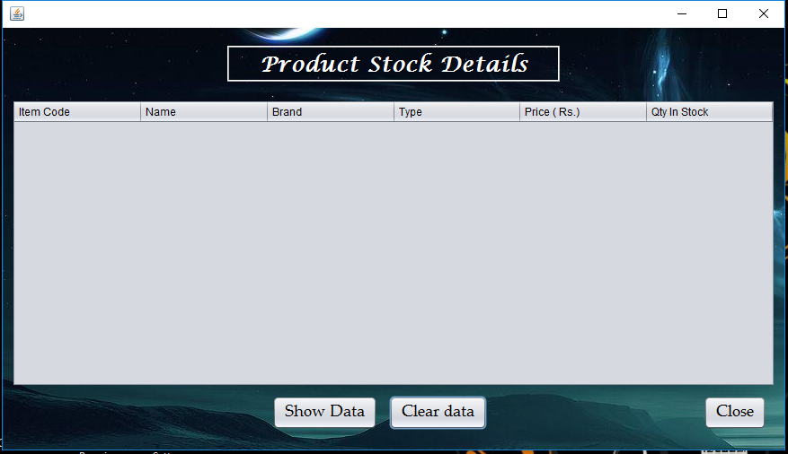

import java.sql.Connection;

import java.sql.DriverManager;

import java.sql.ResultSet;

import java.sql.Statement;

import javax.swing.JOptionPane;

import javax.swing.table.DefaultTableModel;

public class OS_Admin_StockTable extends javax.swing.JFrame {

Connection con;

ResultSet rs;

Statement stmt;

public OS_Admin_StockTable() {

initComponents();

}

private void jButton1ActionPerformed(java.awt.event.ActionEvent evt) {

// TODO add your handling code here:

DefaultTableModel tm= (DefaultTableModel) jTable1.getModel();

try

{ Class.forName("java.sql.DriverManager");

con=DriverManager.getConnection("jdbc:mysql://localhost:3306/onlineshopping", "root","0000");

stmt =con.createStatement();

rs=stmt.executeQuery("select * from products;");

String ic,n,b,t;

int p,s;

while (rs.next()){

ic=rs.getString("Item_code");

n=rs.getString("Item_name");

b=rs.getString("BrandName");

t=rs.getString("Type");

p=rs.getInt("Price");

s=rs.getInt("Stock");

Object rec[]={ic,n,b,t,p,s};

tm.addRow(rec);

}

rs.close();

} catch(Exception e)

{

System.out.println(e.getMessage());

}

}

private void jButton3ActionPerformed(java.awt.event.ActionEvent evt) {

// TODO add your handling code here:

int n;

n=JOptionPane.showConfirmDialog(rootPane,"Do you want to exit ?");

if(n==0)

{

this.dispose();

new OS_Admin_console().setVisible(true);

}

}

private void jButton2ActionPerformed(java.awt.event.ActionEvent evt) {

// TODO add your handling code here:

DefaultTableModel m=(DefaultTableModel) jTable1.getModel();

int x= m.getRowCount();

for(int i=0;i<x;i++)

m.removeRow(0);

}

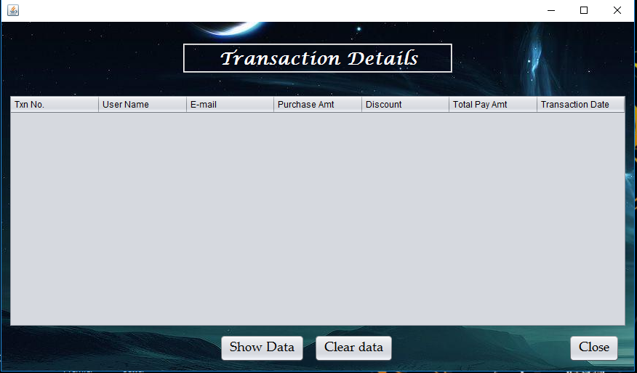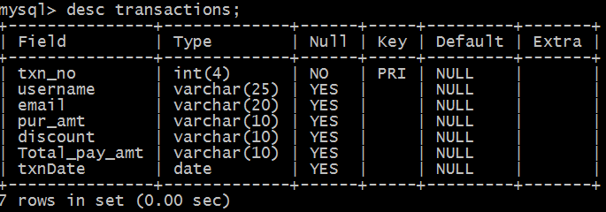

import java.sql.Connection;

import java.sql.DriverManager;

import java.sql.ResultSet;

import java.sql.Statement;

import javax.swing.JOptionPane;

import javax.swing.table.DefaultTableModel;

public class OS_Admin_transactions extends javax.swing.JFrame {

Connection con;

ResultSet rs;

Statement stmt;

public OS_Admin_transactions() {

initComponents();

}

private void jButton1ActionPerformed(java.awt.event.ActionEvent evt) {

// TODO add your handling code here:

DefaultTableModel tm= (DefaultTableModel) jTable1.getModel();

try

{ Class.forName("java.sql.DriverManager");

con=DriverManager.getConnection("jdbc:mysql://localhost:3306/onlineshopping", "root","0000");

stmt =con.createStatement();

rs=stmt.executeQuery("select * from transactions;");

String un,em,pa,dis,ta,dt;

int tn;

while (rs.next()){

tn=rs.getInt(1);

un=rs.getString(2);

em=rs.getString(3);

pa=rs.getString(4);

dis=rs.getString(5);

ta=rs.getString(6);

dt=rs.getString(7);

Object rec[]={tn,un,em,pa,dis,ta,dt};

tm.addRow(rec);

}

rs.close();

} catch(Exception e)

{

System.out.println(e.getMessage());

}

}

private void jButton2ActionPerformed(java.awt.event.ActionEvent evt) {

// TODO add your handling code here:

DefaultTableModel m=(DefaultTableModel) jTable1.getModel();

int x= m.getRowCount();

for(int i=0;i<x;i++)

m.removeRow(0);

}

private void jButton3ActionPerformed(java.awt.event.ActionEvent evt) {

// TODO add your handling code here:

int n;

n=JOptionPane.showConfirmDialog(rootPane,"Do you want to exit ?");

if(n==0)

{

this.dispose();

new OS_Admin_console().setVisible(true);

}

}

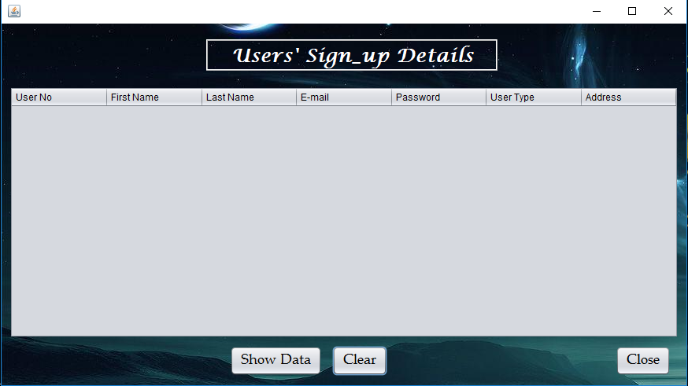

package online.shopping;

import java.sql.Connection;

import java.sql.DriverManager;

import java.sql.ResultSet;

import java.sql.Statement;

import javax.swing.JOptionPane;

import javax.swing.table.DefaultTableModel;

public class OS_Admin_SignUpTable extends javax.swing.JFrame {

Connection con;

ResultSet rs;

Statement stmt;

public OS_Admin_SignUpTable() {

initComponents();

}

private void jButton1ActionPerformed(java.awt.event.ActionEvent evt) {

// TODO add your handling code here:

DefaultTableModel tm= (DefaultTableModel) jTable1.getModel();

try

{ Class.forName("java.sql.DriverManager");

con=DriverManager.getConnection("jdbc:mysql://localhost:3306/onlineshopping", "root","0000");

stmt =con.createStatement();

rs=stmt.executeQuery("select * from Sign_Up;");

String f,l,e,p,ut,a;

int un;

while (rs.next()){

un=rs.getInt("User_No");

f=rs.getString("first_name");

l=rs.getString("last_name");

e=rs.getString("email");

p=rs.getString("password");

ut=rs.getString("user_type");

a=rs.getString("address");

Object rec[]={un,f,l,e,p,ut,a};

tm.addRow(rec);

}

rs.close();

} catch(Exception e)

{

System.out.println(e.getMessage());

}

}

private void jButton2ActionPerformed(java.awt.event.ActionEvent evt) {

// TODO add your handling code here:

DefaultTableModel m=(DefaultTableModel) jTable1.getModel();

int x= m.getRowCount();

for(int i=0;i<x;i++)

m.removeRow(0);

}

private void jButton3ActionPerformed(java.awt.event.ActionEvent evt) {

// TODO add your handling code here:

int n;

n=JOptionPane.showConfirmDialog(rootPane,"Do you want to exit ?");

if(n==0)

{

this.dispose();

new OS_Admin_console().setVisible(true);

}

}

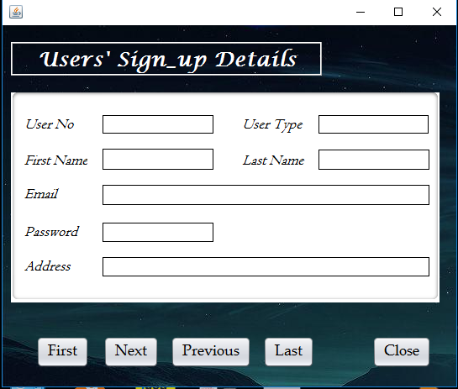

import com.mysql.jdbc.Connection;

import com.mysql.jdbc.Statement;

import java.sql.DriverManager;

import java.sql.ResultSet;

import javax.swing.JOptionPane;

public class OS_Admin_SignUpForm extends javax.swing.JFrame {

Connection con;

Statement stmt;

ResultSet rs;

String qry="select * from Sign_up";

public OS_Admin_SignUpForm() {

initComponents();

try{

Class.forName("java.sql.DriverManager");

con=(Connection)DriverManager.getConnection("jdbc:mysql://localhost:3306/onlineshopping", "root","0000");

stmt = (Statement)con.createStatement();

rs=stmt.executeQuery(qry);

}

catch(Exception e){

JOptionPane.showMessageDialog(rootPane,e.getMessage());

}

}

private void jButton3ActionPerformed(java.awt.event.ActionEvent evt) {

// TODO add your handling code here:

try

{

rs.first();

lblUNo.setText(""+rs.getInt(1));

lblFName.setText(rs.getString(2));

lblLName.setText(rs.getString(3));

lblEmail.setText(rs.getString(4));

lblPass.setText(rs.getString(5));

lblUType.setText(rs.getString(6));

lblAdd.setText(rs.getString(7));

}

catch(Exception e)

{

System.out.println(e.getMessage());

}

}

private void jButton4ActionPerformed(java.awt.event.ActionEvent evt) {

// TODO add your handling code here:

try

{

rs.next();

lblUNo.setText(""+rs.getInt(1));

lblFName.setText(rs.getString(2));

lblLName.setText(rs.getString(3));

lblEmail.setText(rs.getString(4));

lblPass.setText(rs.getString(5));

lblUType.setText(rs.getString(6));

lblAdd.setText(rs.getString(7));

}

catch(Exception e)

{

System.out.println(e.getMessage());

}

}

private void jButton5ActionPerformed(java.awt.event.ActionEvent evt) {

// TODO add your handling code here:

try

{

rs.previous();

lblUNo.setText(""+rs.getInt(1));

lblFName.setText(rs.getString(2));

lblLName.setText(rs.getString(3));

lblEmail.setText(rs.getString(4));

lblPass.setText(rs.getString(5));

lblUType.setText(rs.getString(6));

lblAdd.setText(rs.getString(7));

}

catch(Exception e)

{

System.out.println(e.getMessage());

}

}

private void jButton6ActionPerformed(java.awt.event.ActionEvent evt) {

// TODO add your handling code here:

try

{

rs.last();

lblUNo.setText(""+rs.getInt(1));

lblFName.setText(rs.getString(2));

lblLName.setText(rs.getString(3));

lblEmail.setText(rs.getString(4));

lblPass.setText(rs.getString(5));

lblUType.setText(rs.getString(6));

lblAdd.setText(rs.getString(7));

}

catch(Exception e)

{

System.out.println(e.getMessage());

}

}

private void jButton8ActionPerformed(java.awt.event.ActionEvent evt) {

// TODO add your handling code here:

int n;

n=JOptionPane.showConfirmDialog(rootPane,"Do you want to exit ?");

if(n==0)

{

this.dispose();

new OS_Admin_console().setVisible(true);

}

}



private void jButton1ActionPerformed(java.awt.event.ActionEvent evt) {

// TODO add your handling code here:

new OS_Menz().setVisible(true);

}

private void jButton2ActionPerformed(java.awt.event.ActionEvent evt) {

// TODO add your handling code here:

new OS_Womenz().setVisible(true);

}

private void jButton33ActionPerformed(java.awt.event.ActionEvent evt) {

// TODO add your handling code here:

new OS_Billing_window().setVisible(true);

}

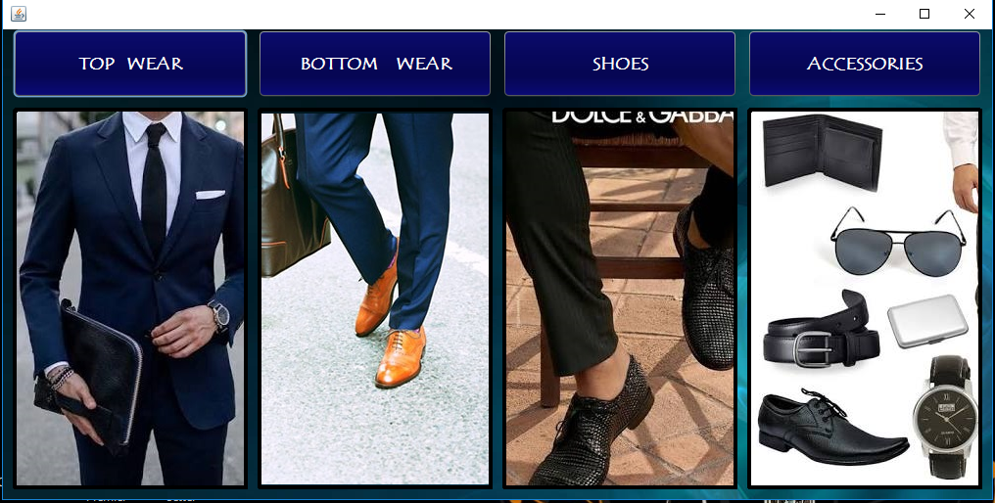

private void TopWearActionPerformed(java.awt.event.ActionEvent evt) {

// TODO add your handling code here:

new OS_Menz_Topwear().setVisible(true);

}

private void BottomWearActionPerformed(java.awt.event.ActionEvent evt) {

// TODO add your handling code here:

new OS_Menz_Jeans().setVisible(true);

}

private void ShoesActionPerformed(java.awt.event.ActionEvent evt) {

// TODO add your handling code here:

new OS_Menz_Shoes().setVisible(true);

}

private void AccessoriesActionPerformed(java.awt.event.ActionEvent evt) {

// TODO add your handling code here:

new OS_Menz_Accessories().setVisible(true);

}

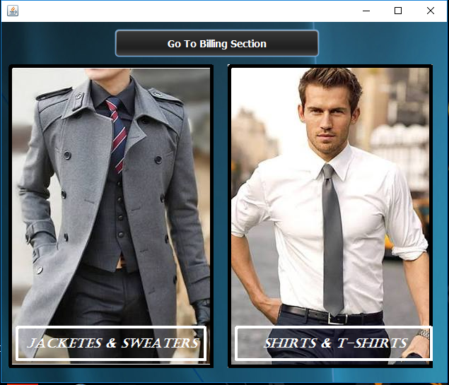

private void jButton3ActionPerformed(java.awt.event.ActionEvent evt) {

// TODO add your handling code here:

new OS_Menz_Jacket().setVisible(true);

}

private void jButton4ActionPerformed(java.awt.event.ActionEvent evt) {

// TODO add your handling code here:

new OS_Menz_Shirt().setVisible(true);

}

private void jButton33ActionPerformed(java.awt.event.ActionEvent evt) {

// TODO add your handling code here:

new OS_Billing_window().setVisible(true);

}

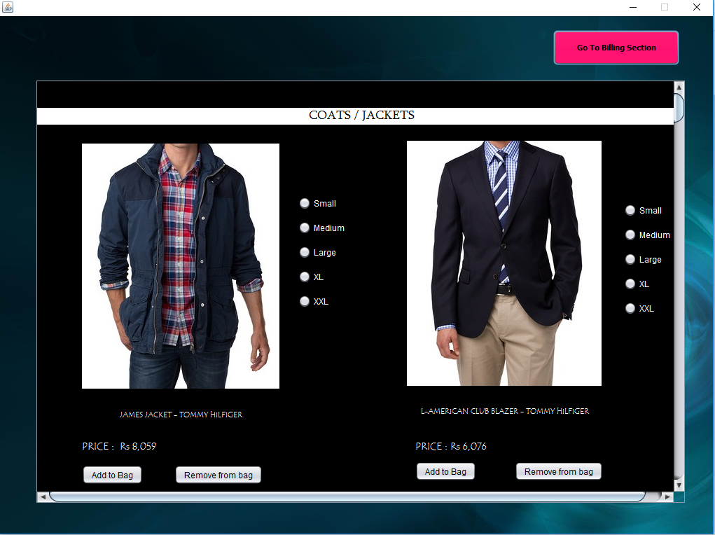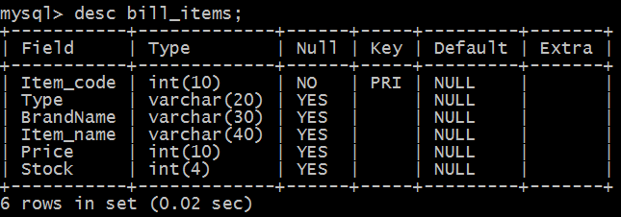

import java.sql.*;

import javax.swing.JOptionPane;

public class OS_Menz_Jacket extends javax.swing.JFrame {

Connection con = null;

Statement stmt = null;

ResultSet rs= null;

int icode, p,s;

String bname, iname, t;

public OS_Menz_Jacket() {

initComponents();

try{Class.forName("com.mysql.jdbc.Driver");

con = DriverManager.getConnection("jdbc:mysql://localhost/onlineshopping","root","0000");

stmt= con.createStatement();

rs.close();

stmt.close();

con.close();

}

catch(Exception e)

{System.out.println(e.getMessage());}

}

private void jButton4ActionPerformed(java.awt.event.ActionEvent evt) {

// TODO add your handling code here:

try{

rs = stmt.executeQuery("select * from products where item_code= 1119;");

while(rs.next()){

icode = rs.getInt("item_code");

p = rs.getInt("price");

bname = rs.getString("brandname");

iname = rs.getString("item_name");

t = rs.getString("type");

s=rs.getInt("stock");

}

rs.close();

stmt.close();

con.close();

}

catch(Exception e)

{JOptionPane.showMessageDialog(rootPane,e.getMessage());}

try{Class.forName("com.mysql.jdbc.Driver");

con = DriverManager.getConnection("jdbc:mysql://localhost/onlineshopping","root","0000");

stmt= con.createStatement();

int a = stmt.executeUpdate("insert into bill_items values("+icode+", '"+ t +"' , '"+ bname+"','"+ iname + "','"+ p +"','"+s+ "');");

JOptionPane.showMessageDialog(rootPane,"Added Succesfully");

}

catch(Exception e)

{JOptionPane.showMessageDialog(rootPane,e.getMessage());}

}

private void jButton5ActionPerformed(java.awt.event.ActionEvent evt) {

// TODO add your handling code here:

try{Class.forName("com.mysql.jdbc.Driver");

con = DriverManager.getConnection("jdbc:mysql://localhost/onlineshopping","root","0000");

stmt= con.createStatement();

int a = stmt.executeUpdate("Delete from bill_items where item_code = 1119;");

rs.close();

stmt.close();

con.close();

JOptionPane.showMessageDialog(rootPane,"Removed Succesfully");

}

catch(Exception e)

{JOptionPane.showMessageDialog(rootPane,e.getMessage());}

}

private void jButton1ActionPerformed(java.awt.event.ActionEvent evt) {

// TODO add your handling code here:

new OS_Billing_window().setVisible(true);

}

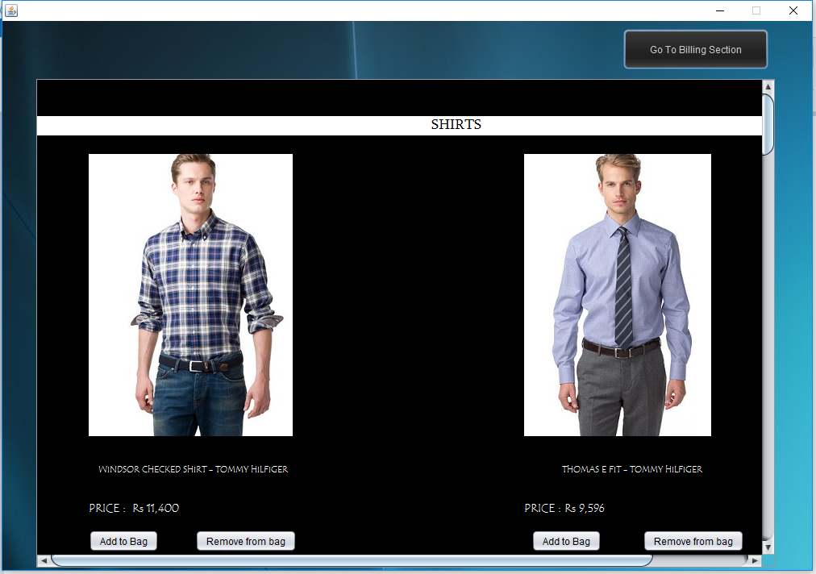

import java.sql.*;

import javax.swing.JOptionPane;

public class OS_Menz_Shirt extends javax.swing.JFrame {

Connection con = null;

Statement stmt = null;

ResultSet rs= null;

int icode, p,s;

String bname, iname, t;

public OS_Menz_Shirt() {

initComponents();

try{Class.forName("com.mysql.jdbc.Driver");

con = DriverManager.getConnection("jdbc:mysql://localhost/onlineshopping","root","0000");

stmt= con.createStatement();

}

catch(Exception e)

{System.out.println(e.getMessage());}

}

private void AddToBag1ActionPerformed(java.awt.event.ActionEvent evt) {

// TODO add your handling code here:

try{

rs = stmt.executeQuery("select * from products where item_code= 1090;");

while(rs.next()){

icode = rs.getInt("item_code");

p = rs.getInt("price");

bname = rs.getString("brandname");

iname = rs.getString("item_name");

t = rs.getString("type");

s=rs.getInt("stock");

System.out.println(""+icode+p+bname+iname+t+s);

}

rs.close();

stmt.close();

con.close();

}

catch(Exception e)

{JOptionPane.showMessageDialog(rootPane,e.getMessage());}

try{Class.forName("com.mysql.jdbc.Driver");

con = DriverManager.getConnection("jdbc:mysql://localhost/onlineshopping","root","0000");

stmt= con.createStatement();

int a = stmt.executeUpdate("insert into bill_items values("+icode+", '"+ t +"' , '"+ bname+"','"+ iname + "','"+ p +"','"+ s + "')");

JOptionPane.showMessageDialog(rootPane,"Added Succesfully");

}

catch(Exception e)

{JOptionPane.showMessageDialog(rootPane,e.getMessage());}

}

private void RemoveFromeBag1ActionPerformed(java.awt.event.ActionEvent evt) {

// TODO add your handling code here:

try{Class.forName("com.mysql.jdbc.Driver");

con = DriverManager.getConnection("jdbc:mysql://localhost/onlineshopping","root","0000");

stmt= con.createStatement();

int a = stmt.executeUpdate("Delete from bill_items where item_code = 1090;");

rs.close();

stmt.close();

con.close();

JOptionPane.showMessageDialog(rootPane,"Removed Succesfully");

}

catch(Exception e)

{JOptionPane.showMessageDialog(rootPane,e.getMessage());}

}

private void GoToBillingSectionActionPerformed(java.awt.event.ActionEvent evt) {

// TODO add your handling code here:

new OS_Billing_window().setVisible(true);

}

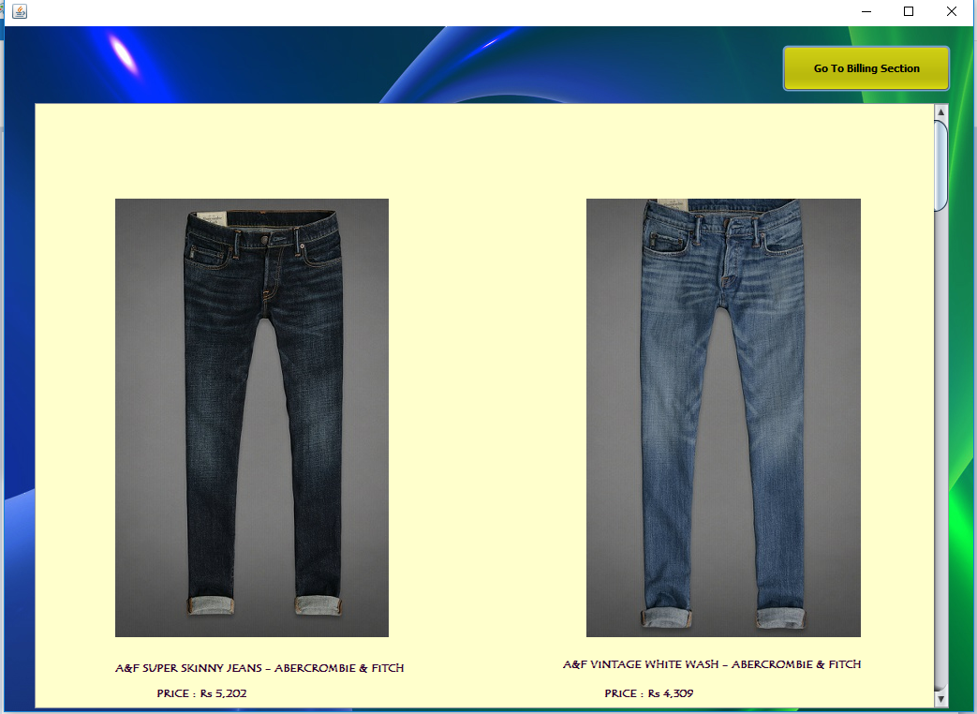

import java.sql.*;

import javax.swing.JOptionPane;

public class OS_Menz_Jeans extends javax.swing.JFrame {

Connection con = null;

Statement stmt = null;

ResultSet rs= null;

int icode, p,s;

String bname, iname, t;

public OS_Menz_Jeans() {

initComponents();

try{Class.forName("com.mysql.jdbc.Driver");

con = DriverManager.getConnection("jdbc:mysql://localhost/onlineshopping","root","0000");

stmt= con.createStatement();

rs.close();

stmt.close();

con.close();

}

catch(Exception e)

{System.out.println(e.getMessage());}

}

private void jButton1ActionPerformed(java.awt.event.ActionEvent evt) {

// TODO add your handling code here:

try{

rs = stmt.executeQuery("select * from products where item_code= 1056;");

while(rs.next()){

icode = rs.getInt("item_code");

p = rs.getInt("price");

bname = rs.getString("brandname");

iname = rs.getString("item_name");

t = rs.getString("type");

s=rs.getInt("stock");

}

rs.close();

stmt.close();

con.close();

}

catch(Exception e)

{JOptionPane.showMessageDialog(rootPane,e.getMessage());}

try{Class.forName("com.mysql.jdbc.Driver");

con = DriverManager.getConnection("jdbc:mysql://localhost/onlineshopping","root","0000");

stmt= con.createStatement();

int a = stmt.executeUpdate("insert into bill_items values("+icode+", '"+ t +"' , '"+ bname+"','"+ iname + "','"+ p +"','"+s+ "');");

JOptionPane.showMessageDialog(rootPane,"Added Succesfully");

}

catch(Exception e)

{JOptionPane.showMessageDialog(rootPane,e.getMessage());}

}

private void jButton2ActionPerformed(java.awt.event.ActionEvent evt) {

// TODO add your handling code here:

try{Class.forName("com.mysql.jdbc.Driver");

con = DriverManager.getConnection("jdbc:mysql://localhost/onlineshopping","root","0000");

stmt= con.createStatement();

int a = stmt.executeUpdate("Delete from bill_items where item_code = 1056;");

rs.close();

stmt.close();

con.close();

JOptionPane.showMessageDialog(rootPane,"Removed Succesfully");

}

catch(Exception e)

{JOptionPane.showMessageDialog(rootPane,e.getMessage());}

}

private void jButton23ActionPerformed(java.awt.event.ActionEvent evt) {

// TODO add your handling code here:

new OS_Billing_window().setVisible(true);

}

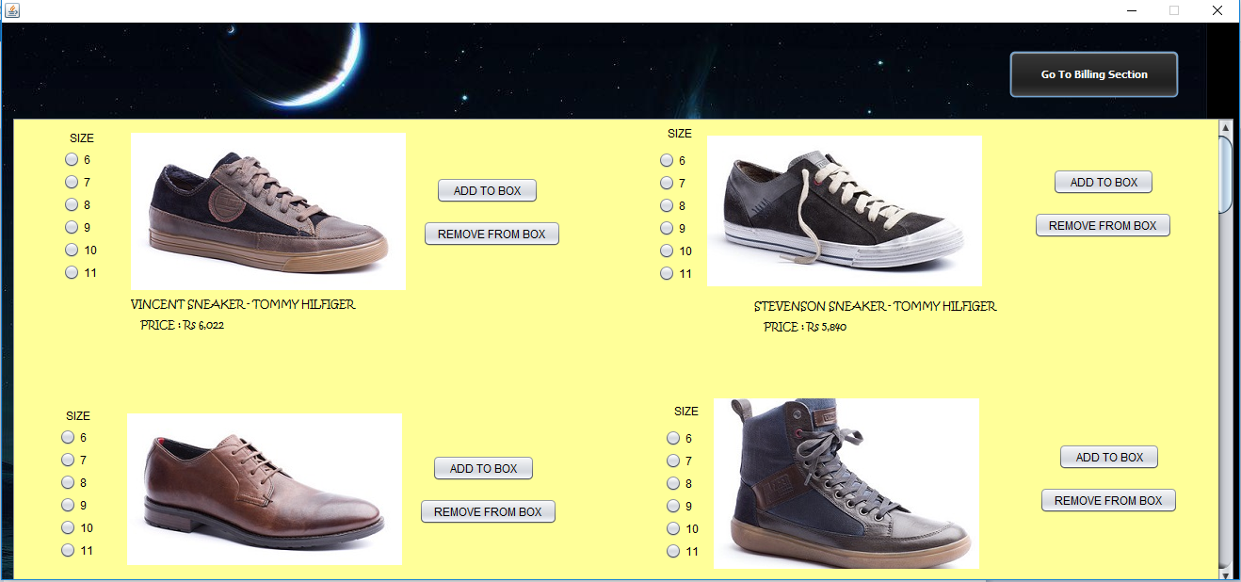

import java.sql.*;

import javax.swing.JOptionPane;

public class OS_Menz_Shoes extends javax.swing.JFrame {

Connection con = null;

Statement stmt = null;

ResultSet rs= null;

int icode, p,s;

String bname, iname, t;

public OS_Menz_Shoes() {

initComponents();

try{Class.forName("com.mysql.jdbc.Driver");

con = DriverManager.getConnection("jdbc:mysql://localhost/onlineshopping","root","0000");

stmt= con.createStatement();

rs.close();

stmt.close();

con.close();

}

catch(Exception e)

{System.out.println(e.getMessage());}

}

private void jButton1ActionPerformed(java.awt.event.ActionEvent evt) {

// TODO add your handling code here:

try{

rs = stmt.executeQuery("select * from products where item_code= 1067;");

while(rs.next()){

icode = rs.getInt("item_code");

p = rs.getInt("price");

bname = rs.getString("brandname");

iname = rs.getString("item_name");

t = rs.getString("type");

s=rs.getInt("stock");

}

rs.close();

stmt.close();

con.close();

}

catch(Exception e)

{JOptionPane.showMessageDialog(rootPane,e.getMessage());}

try{Class.forName("com.mysql.jdbc.Driver");

con = DriverManager.getConnection("jdbc:mysql://localhost/onlineshopping","root","0000");

stmt= con.createStatement();

int a = stmt.executeUpdate("insert into bill_items values("+icode+", '"+ t +"' , '"+ bname+"','"+ iname + "','"+ p +"','"+s+ "');");

JOptionPane.showMessageDialog(rootPane,"Added Succesfully");

}

catch(Exception e)

{JOptionPane.showMessageDialog(rootPane,e.getMessage());}

}

private void jButton2ActionPerformed(java.awt.event.ActionEvent evt) {

// TODO add your handling code here:

try{Class.forName("com.mysql.jdbc.Driver");

con = DriverManager.getConnection("jdbc:mysql://localhost/onlineshopping","root","0000");

stmt= con.createStatement();

int a = stmt.executeUpdate("Delete from bill_items where item_code = 1067;");

rs.close();

stmt.close();

con.close();

JOptionPane.showMessageDialog(rootPane,"Removed Succesfully");

}

catch(Exception e)

{JOptionPane.showMessageDialog(rootPane,e.getMessage());}

}

private void jButton33ActionPerformed(java.awt.event.ActionEvent evt) {

// TODO add your handling code here:

new OS_Billing_window().setVisible(true);

}

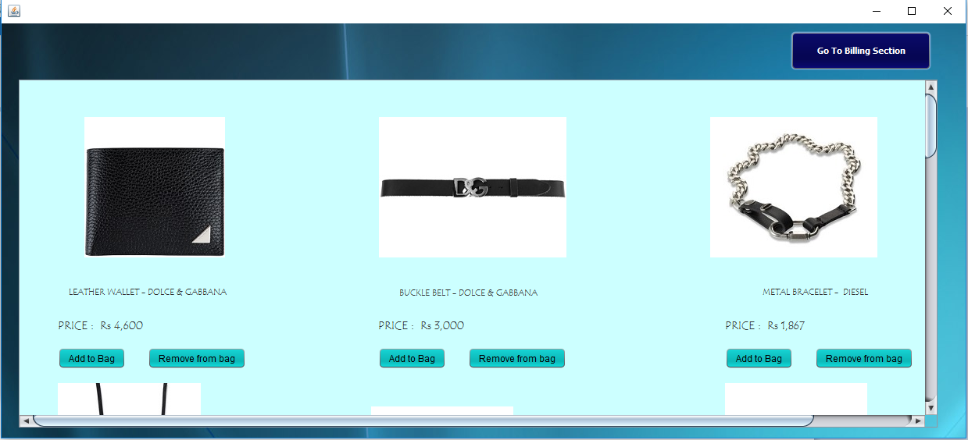

import java.sql.*;

import javax.swing.JOptionPane;

public class OS_Menz_Accessories extends javax.swing.JFrame {

Connection con = null;

Statement stmt = null;

ResultSet rs= null;

int icode,p,s;

String bname, iname, t;

public OS_Menz_Accessories() {

initComponents();

try{Class.forName("com.mysql.jdbc.Driver");

con = DriverManager.getConnection("jdbc:mysql://localhost/onlineshopping","root","0000");

stmt= con.createStatement();

rs.close();

stmt.close();

con.close();

}

catch(Exception e)

{System.out.println(e.getMessage());}

}

private void jButton81ActionPerformed(java.awt.event.ActionEvent evt) {

// TODO add your handling code here:

try{

rs = stmt.executeQuery("select * from products where item_code= 1104;");

while(rs.next()){

icode = rs.getInt("item_code");

p = rs.getInt("price");

bname = rs.getString("brandname");

iname = rs.getString("item_name");

t = rs.getString("type");

s=rs.getInt("stock");

}

rs.close();

stmt.close();

con.close();

}

catch(Exception e)

{JOptionPane.showMessageDialog(rootPane,e.getMessage());}

try{Class.forName("com.mysql.jdbc.Driver");

con = DriverManager.getConnection("jdbc:mysql://localhost/onlineshopping","root","0000");

stmt= con.createStatement();

int a = stmt.executeUpdate("insert into bill_items values("+icode+", '"+ t +"' , '"+ bname+"','"+ iname + "','"+ p +"','"+ s + "')");

JOptionPane.showMessageDialog(rootPane,"Added Succesfully");

}

catch(Exception e)

{JOptionPane.showMessageDialog(rootPane,e.getMessage());}

}

private void jButton80ActionPerformed(java.awt.event.ActionEvent evt) {

// TODO add your handling code here:

try{Class.forName("com.mysql.jdbc.Driver");

con = DriverManager.getConnection("jdbc:mysql://localhost/onlineshopping","root","0000");

stmt= con.createStatement();

int a = stmt.executeUpdate("Delete from bill_items where item_code = 1104;");

rs.close();

stmt.close();

con.close();

JOptionPane.showMessageDialog(rootPane,"Removed Succesfully");

}

catch(Exception e)

{JOptionPane.showMessageDialog(rootPane,e.getMessage());}

}

private void jButton1ActionPerformed(java.awt.event.ActionEvent evt) {

// TODO add your handling code here:

new OS_Billing_window().setVisible(true);

}

Women’S SECTION

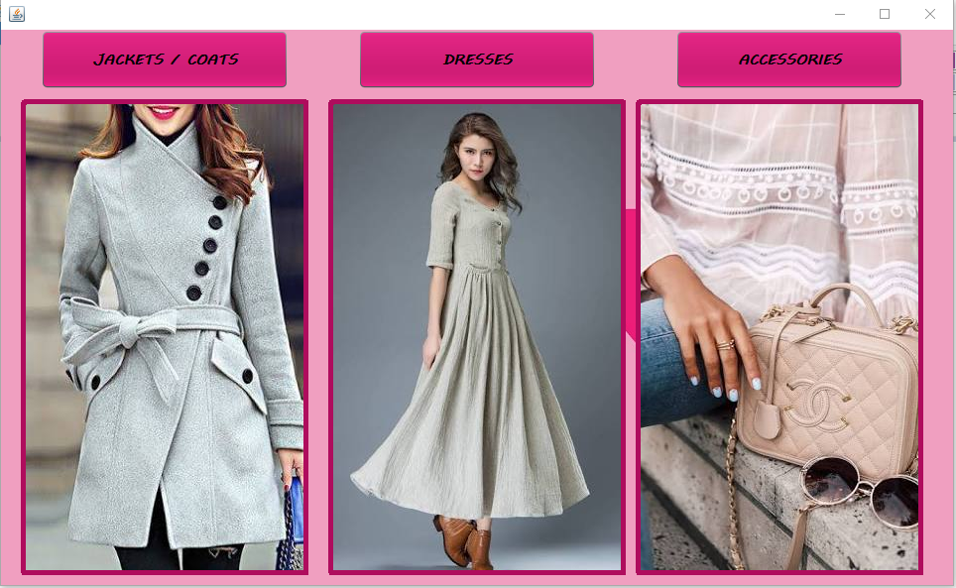

private void accessoriesActionPerformed(java.awt.event.ActionEvent evt) {

// TODO add your handling code here:

new OS_Womenz_Accessories().setVisible(true);

}

private void dressesActionPerformed(java.awt.event.ActionEvent evt) {

// TODO add your handling code here:

new OS_Womenz_Dresses().setVisible(true);

}

private void jacketsActionPerformed(java.awt.event.ActionEvent evt) {

// TODO add your handling code here:

new OS_Womenz_Jacket().setVisible(true);

}

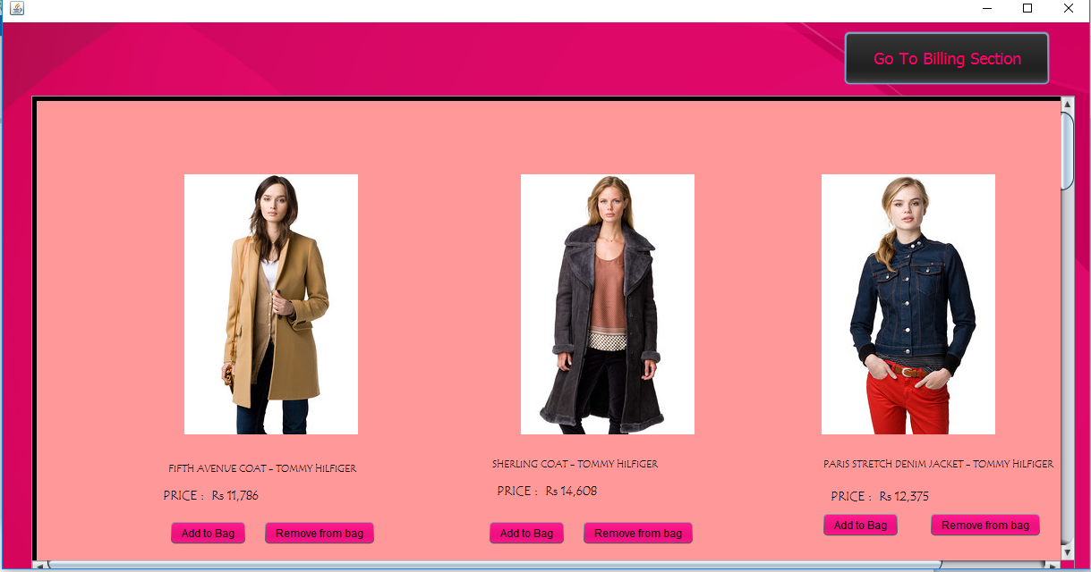

import java.sql.*;

import javax.swing.JOptionPane;

public class OS_Womenz_Jacket extends javax.swing.JFrame {

Connection con = null;

Statement stmt = null;

ResultSet rs= null;

int icode, p,s;

String bname, iname, t;

public OS_Womenz_Jacket() {

initComponents();

try{Class.forName("com.mysql.jdbc.Driver");

con = DriverManager.getConnection("jdbc:mysql://localhost/onlineshopping","root","0000");

stmt= con.createStatement();

rs.close();

stmt.close();

con.close();

}

catch(Exception e)

{System.out.println(e.getMessage());}

}

private void AddToBagActionPerformed(java.awt.event.ActionEvent evt) {

// TODO add your handling code here:

try{

rs = stmt.executeQuery("select * from products where item_code= 1001;");

while(rs.next()){

icode = rs.getInt("item_code");

p = rs.getInt("price");

bname = rs.getString("brandname");

iname = rs.getString("item_name");

t = rs.getString("type");

s = rs.getInt("stock");

s = rs.getInt("stock");

}

rs.close();

stmt.close();

con.close();

}

catch(Exception e)

{JOptionPane.showMessageDialog(rootPane,e.getMessage());}

try{Class.forName("com.mysql.jdbc.Driver");

con = DriverManager.getConnection("jdbc:mysql://localhost/onlineshopping","root","0000");

stmt= con.createStatement();

int a = stmt.executeUpdate("insert into bill_items values("+icode+", '"+ t +"' , '"+ bname+"','"+ iname + "','"+ p +"','"+ s + "')");

JOptionPane.showMessageDialog(rootPane,"Added Succesfully");

}

catch(Exception e)

{JOptionPane.showMessageDialog(rootPane,e.getMessage());}

}

private void RemoveFromBagActionPerformed(java.awt.event.ActionEvent evt) {

// TODO add your handling code here:

try{Class.forName("com.mysql.jdbc.Driver");

con = DriverManager.getConnection("jdbc:mysql://localhost/onlineshopping","root","0000");

stmt= con.createStatement();

int a = stmt.executeUpdate("Delete from bill_items where item_code = 1001;");

rs.close();

stmt.close();

con.close();

JOptionPane.showMessageDialog(rootPane,"Removed Succesfully");

}

catch(Exception e)

{JOptionPane.showMessageDialog(rootPane,e.getMessage());}

}

private void jButton1ActionPerformed(java.awt.event.ActionEvent evt) {

// TODO add your handling code here:

new OS_Billing_window().setVisible(true);

}

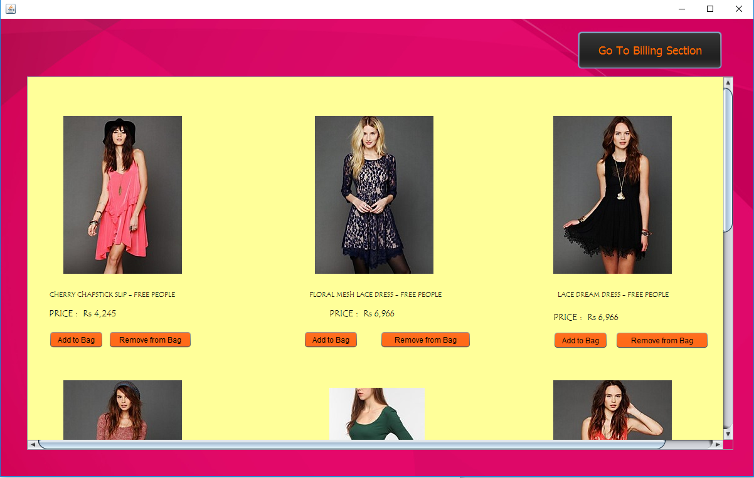

import java.sql.*;

import javax.swing.JOptionPane;

public class OS_Womenz_Dresses extends javax.swing.JFrame {

Connection con = null;

Statement stmt = null;

ResultSet rs= null;

int icode, p,s;

String bname, iname, t;

public OS_Womenz_Dresses() {

initComponents();

try{Class.forName("com.mysql.jdbc.Driver");

con = DriverManager.getConnection("jdbc:mysql://localhost/onlineshopping","root","0000");

stmt= con.createStatement();

rs.close();

stmt.close();

con.close();

}

catch(Exception e)

{System.out.println(e.getMessage());}

}

private void jButton67ActionPerformed(java.awt.event.ActionEvent evt) {

// TODO add your handling code here:

try{

rs = stmt.executeQuery("select * from products where item_code= 1018;");

while(rs.next()){

icode = rs.getInt("item_code");

p = rs.getInt("price");

bname = rs.getString("brandname");

iname = rs.getString("item_name");

t = rs.getString("type");

s = rs.getInt("stock");

}

rs.close();

stmt.close();

con.close();

}

catch(Exception e)

{JOptionPane.showMessageDialog(rootPane,e.getMessage());}

try{Class.forName("com.mysql.jdbc.Driver");

con = DriverManager.getConnection("jdbc:mysql://localhost/onlineshopping","root","0000");

stmt= con.createStatement();

int a = stmt.executeUpdate("insert into bill_items values("+icode+", '"+ t +"' , '"+ bname+"','"+ iname + "','"+ p +"','"+ s + "')");

JOptionPane.showMessageDialog(rootPane,"Added Succesfully");

}

catch(Exception e)

{JOptionPane.showMessageDialog(rootPane,e.getMessage());}

}

private void jButton68ActionPerformed(java.awt.event.ActionEvent evt) {

// TODO add your handling code here:

try{Class.forName("com.mysql.jdbc.Driver");

con = DriverManager.getConnection("jdbc:mysql://localhost/onlineshopping","root","0000");

stmt= con.createStatement();

int a = stmt.executeUpdate("Delete from bill_items where item_code = 1018;");

rs.close();

stmt.close();

con.close();

JOptionPane.showMessageDialog(rootPane,"Removed Succesfully");

}

catch(Exception e)

{JOptionPane.showMessageDialog(rootPane,e.getMessage());}

}

private void jButton1ActionPerformed(java.awt.event.ActionEvent evt) {

// TODO add your handling code here:

new OS_Billing_window().setVisible(true);

}

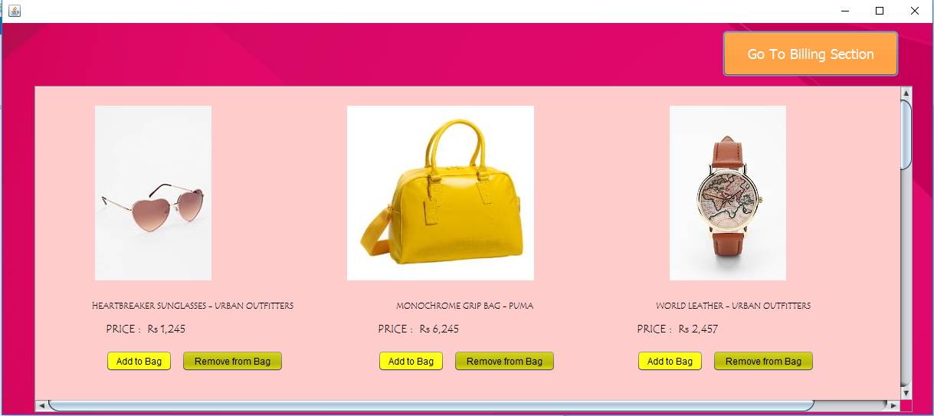

import java.sql.*;

import javax.swing.JOptionPane;

public class OS_Womenz_Accessories extends javax.swing.JFrame {

Connection con = null;

Statement stmt = null;

ResultSet rs= null;

int icode, p,s;

String bname, iname, t;

public OS_Womenz_Accessories() {

initComponents();

try{Class.forName("com.mysql.jdbc.Driver");

con = DriverManager.getConnection("jdbc:mysql://localhost/onlineshopping","root","0000");

stmt= con.createStatement();

rs.close();

stmt.close();

con.close();

}

catch(Exception e)

{System.out.println(e.getMessage());}

}

private void jButton67ActionPerformed(java.awt.event.ActionEvent evt) {

// TODO add your handling code here:

try{

rs = stmt.executeQuery("select * from products where item_code= 1043;");

while(rs.next()){

icode = rs.getInt("item_code");

p = rs.getInt("price");

bname = rs.getString("brandname");

iname = rs.getString("item_name");

t = rs.getString("type");

s = rs.getInt("stock");

}

rs.close();

stmt.close();

con.close();

}

catch(Exception e)

{JOptionPane.showMessageDialog(rootPane,e.getMessage());}

try{Class.forName("com.mysql.jdbc.Driver");

con = DriverManager.getConnection("jdbc:mysql://localhost/onlineshopping","root","0000");

stmt= con.createStatement();

int a = stmt.executeUpdate("insert into bill_items values("+icode+", '"+ t +"' , '"+ bname+"','"+ iname + "','"+ p +"','"+ s + "')");

JOptionPane.showMessageDialog(rootPane,"Added Succesfully");

}

catch(Exception e)

{JOptionPane.showMessageDialog(rootPane,e.getMessage());}

}

private void jButton68ActionPerformed(java.awt.event.ActionEvent evt) {

// TODO add your handling code here:

try{Class.forName("com.mysql.jdbc.Driver");

con = DriverManager.getConnection("jdbc:mysql://localhost/onlineshopping","root","0000");

stmt= con.createStatement();

int a = stmt.executeUpdate("Delete from bill_items where item_code = 1043;");

rs.close();

stmt.close();

con.close();

JOptionPane.showMessageDialog(rootPane,"Removed Succesfully");

}

catch(Exception e)

{JOptionPane.showMessageDialog(rootPane,e.getMessage());}

}

private void jButton1ActionPerformed(java.awt.event.ActionEvent evt) {

// TODO add your handling code here:

new OS_Billing_window().setVisible(true);

}

BILLING WINDOW

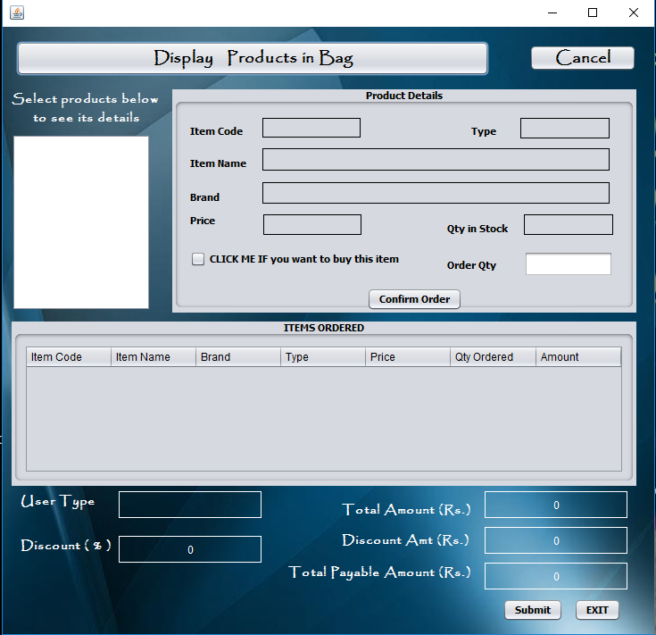

import com.mysql.jdbc.Connection;

import com.mysql.jdbc.Statement;

import java.sql.DriverManager;

import java.sql.ResultSet;

import javax.swing.DefaultListModel;

import javax.swing.JOptionPane;

import javax.swing.table.DefaultTableModel;

public class OS_Billing_window extends javax.swing.JFrame {

Connection con;

Statement stmt;

ResultSet rs;

String qry1,qry="select * from bill_items;";

public OS_Billing_window() {

initComponents();

try

{

Class.forName("java.sql.DriverManager");

con=(Connection)DriverManager.getConnection("jdbc:mysql://localhost:3306/onlineshopping", "root","0000");

stmt = (Statement)con.createStatement(rs.TYPE_FORWARD_ONLY,rs.CONCUR_UPDATABLE);

rs=stmt.executeQuery(qry);

}

catch(Exception e)

{

JOptionPane.showMessageDialog(rootPane,e.getMessage());

}

}

void emptyList(){

DefaultListModel model=(DefaultListModel)listToy.getModel();

while(model.getSize()>0)

model.remove(0); }

private void btnExitActionPerformed(java.awt.event.ActionEvent evt) {

// TODO add your handling code here:

JOptionPane.showMessageDialog(rootPane,"Thank you for using the Online Shopping application");

System.exit(0);

}

private void btnDisplayActionPerformed(java.awt.event.ActionEvent evt) {

// TODO add your handling code here:

emptyList();

int count=0;

String query="select Item_name from bill_items;";

DefaultListModel model=(DefaultListModel)listToy.getModel();

try

{

Class.forName("java.sql.DriverManager");

con =(Connection)DriverManager.getConnection("jdbc:mysql://localhost:3306/onlineshopping", "root","0000");

stmt = (Statement) con.createStatement();

rs =stmt.executeQuery(query);

while(rs.next())

{

model.add(count,rs.getString("Item_name"));

count++;

}

}

catch(Exception e)

{

JOptionPane.showMessageDialog(rootPane,e.getMessage());

}

txtOrdQty.setEnabled(false);

//new connection coding

String ut = null;

String qy="select * from curr_login;";

try{

Class.forName("java.sql.Driver");

con=(Connection)DriverManager.getConnection("jdbc:mysql://localhost/onlineshopping","root","0000");

stmt=(Statement)con.createStatement();

rs = stmt.executeQuery(qy);

while(rs.next())

{

ut=rs.getString("User_type");

}

}

catch (Exception e)

{

System.out.println(e.getMessage());

}

lblUserType.setText(ut);

if (ut.equals("Premium"))

lblDiscountP.setText("20");

else

lblDiscountP.setText("5");

btnDisplay.setEnabled(false);

}

private void btnSubmitActionPerformed(java.awt.event.ActionEvent evt) {

// TODO add your handling code here:

DefaultTableModel model=(DefaultTableModel)tbOrder.getModel();

int count=model.getRowCount();

String total=lblTotPayAmt.getText();

String disAmt=lblDiscount.getText();

String totAmt=lblTotAmt.getText();

int sno;

String fn = null,ln = null,em = null,ut = null,addr = null;

String query="select * from curr_login" ;

try

{

Class.forName("java.sql.DriverManager");

con =(Connection)DriverManager.getConnection("jdbc:mysql://localhost:3306/onlineshopping", "root","0000");

stmt = (Statement) con.createStatement();

rs =stmt.executeQuery(query);

while(rs.next())

{

sno=rs.getInt(1);

fn=rs.getString(2);

ln=rs.getString(3);

em=rs.getString(4);

ut=rs.getString(6);

addr=rs.getString(7);

}

}

catch(Exception e)

{

System.out.println(e.getMessage());

}

if(totAmt.equals("0"))

JOptionPane.showMessageDialog(rootPane,"No item ordered !!!");

else

{

JOptionPane.showMessageDialog(rootPane,"Dear Mr. "+fn+" "+ln

+",\nYou have ordered for "+count+" items and your payable bill amount is Rs."+total+"\n"

+"Being a "+ut+" user , you got a discount of Rs. "+disAmt+"\n\n"

+"Your shipment will reach to your address: "+addr+" within 7-10 days."

+"\nThe bill has been sent to your E-mail address: "+em);

int n=0;

try{

Class.forName("java.sql.DriverManager");

con =(Connection)DriverManager.getConnection("jdbc:mysql://localhost:3306/onlineshopping", "root","0000");

stmt = (Statement) con.createStatement();

rs=stmt.executeQuery("select * from transactions;");

while (rs.last()){

n = rs.getInt("txn_no");

rs.close();

stmt.close();

con.close();

}

}

catch (Exception e)

{

System.out.println(e.getMessage());

}

n=n+1;

String un=fn+" "+ln;

String qy1="insert into transactions values("+n+",'"+un+"','"+em+"','"+totAmt+"','"+disAmt+"','"+total+"',"+"(select sysdate()));";

System.out.println(qy1);

try

{

Class.forName("java.sql.DriverManager");

con =(Connection)DriverManager.getConnection("jdbc:mysql://localhost:3306/onlineshopping", "root","0000");

stmt = (Statement) con.createStatement();

int a=stmt.executeUpdate(qy1);

JOptionPane.showMessageDialog(rootPane,"Transaction completed successfully .");

}

catch (Exception e)

{

System.out.println(e.getMessage());

}

btnSubmit.setEnabled(false);

btnCnfOrd.setEnabled(false);

}

}

private void listToyValueChanged(javax.swing.event.ListSelectionEvent evt) {

// TODO add your handling code here:

chkBuy.setSelected(false);

String selVal=(String)listToy.getSelectedValue();

String query="select * from Bill_items where Item_name='"+ selVal +"';";

try{

Class.forName("java.sql.Driver");

con=(Connection)DriverManager.getConnection("jdbc:mysql://localhost/onlineshopping","root","0000");

stmt=(Statement)con.createStatement();

rs = stmt.executeQuery(query);

rs.next();

{

lblIcode.setText(""+rs.getInt(1));

lblType.setText(rs.getString(2));

lblBrand.setText(rs.getString(3));

lblIName.setText(rs.getString(4));

lblPrice.setText(""+rs.getFloat(5));

lblTqty.setText(""+rs.getInt(6));

}

rs.close();

stmt.close();

con.close();

}

catch(Exception e){

JOptionPane.showMessageDialog(rootPane,e.getMessage());

}

chkBuy.setSelected(false);

}

private void chkBuyActionPerformed(java.awt.event.ActionEvent evt) {

// TODO add your handling code here:

if(chkBuy.isSelected())

txtOrdQty.setEnabled(true);

else txtOrdQty.setEnabled(false);

}

private void btnCnfOrdActionPerformed(java.awt.event.ActionEvent evt) {

// TODO add your handling code here:

int qtyA=Integer.parseInt(lblTqty.getText());

int qtyO=Integer.parseInt(txtOrdQty.getText());

if(chkBuy.isSelected()==false)

JOptionPane.showMessageDialog(rootPane,"Please select order quantity");

else if(qtyO<=0)

JOptionPane.showMessageDialog(rootPane,"Order quantity must not be less than 1 !!!");

else if(qtyO>qtyA)

JOptionPane.showMessageDialog(rootPane,"Only "+ qtyA+" items of Item Code "+ lblIcode.getText()+" are in stock! \n SORRY, Cannot take your order.");

else{

float amt=qtyO*(Float.parseFloat(lblPrice.getText()));

float total=Float.parseFloat(lblTotAmt.getText());

DefaultTableModel model=(DefaultTableModel)tbOrder.getModel();

int tc=Integer.parseInt(lblIcode.getText());

qry="UPDATE Bill_items SET stock=stock-"+qtyO+" where Item_code="+tc+";";

qry1="UPDATE Products SET stock=stock-"+qtyO+" where Item_code="+tc+";";

try

{

Class.forName("java.sql.DriverManager");

con = (Connection)DriverManager.getConnection("jdbc:mysql://localhost:3306/onlineshopping", "root","0000");

stmt =(Statement)con.createStatement(rs.TYPE_FORWARD_ONLY,rs.CONCUR_UPDATABLE);

stmt.executeUpdate(qry);

stmt.executeUpdate(qry1);

//now adding to order table

model.addRow(new Object[]{

lblIcode.getText(),lblIName.getText(),lblBrand.getText(),lblType.getText(),lblPrice.getText(),txtOrdQty.getText(),amt });

total=total+amt;

lblTotAmt.setText(""+total);

Float disP,disAmt,totPayAmt;

Float totAmt=Float.parseFloat(lblTotAmt.getText());

disP=Float.parseFloat(lblDiscountP.getText());

disAmt=totAmt*disP/100;

totPayAmt=totAmt-disAmt;

lblDiscount.setText(""+disAmt);

lblTotPayAmt.setText(""+totPayAmt);

}

catch(Exception e){

JOptionPane.showMessageDialog(rootPane,e.getMessage());

}

txtOrdQty.setText("");

txtOrdQty.setEnabled(false);

chkBuy.setSelected(false);

}

}

private void btnCancelActionPerformed(java.awt.event.ActionEvent evt) {

// TODO add your handling code here:

this.setVisible(false);

}

USER MANUAL

## How to install Software:

### Hardware Requirement-

* Intel Pentium/Celeron or similar processor based PC at Client/Server end.
* 128 MB RAM and 4GB HDD space (for Database) is desirable.
* Standard I/O devices like Keyboard and Mouse etc.
* Printer is needed for hard-copy reports.
* Local Area Network (LAN) is required for Client-Server Installation

### Software Requirement-

* Windows XP/2007 OS is desirable.
* NetBeans Ver 7.2 or higher should be installed with JDK and JVM.
* MySQL Ver 6.1 with onlineshopping Database must be present at machine.

### Database Installation

The software project is distributed with a backup copy of a Database named **onlineshopping** with required tables. Some dummy records are present in the tables for testing purposes, which can be deleted before inserting real data. The project is shipped with **onlineshopping.sql** file which installs a database and tables in the computer system.

Note: The PC must have MySQL server with user (***root***) and password (***0000***). If root password is any other password, it can be changed by running MySQL Server Instance Configure Wizard.

Start ⏵Program ⏵ MySQL ⏵MySQL Server ⏵MySQL Server Instance Config Wizard

Provide current password of root and new password as “**0000**”, this will change the root password.

To install a MySQL database from a dump file ***(onlineshopping.sql)***, simply follow the following steps.

**Step 1:** Copy the onlineshopping.sql file in **C:\Program files\MySQL\MySQL server**

**5.1\Bin** folder.

**Step 2:** Open MySQL and type the following command to create the database

mysql> create database onlineshopping;

**Step 3:** Open Command Window (Start ⏵Run ⏵ cmd)

**Step 4:** Go to the following folder using CD command of DOS.

**C:\Program files\Mysql\MySQL server 5.1\Bin>**

**Step 5:** type the following command on above prompt -

**C:….\bin>** mysql -u ***root*** –p***0000*** onlineshopping < onlineshopping.sql

This will create a onlineshopping database with required tables.

## 

## Working with Software Project:

The New Clothing Store consists of the following logically organised structure for the easy functionality. User may choose the options for corresponding works.

 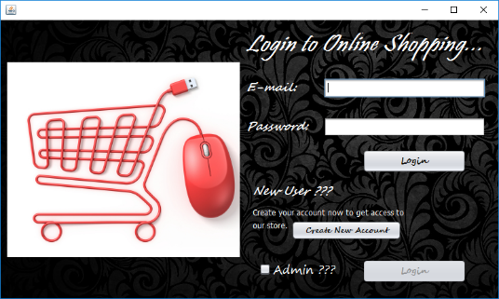 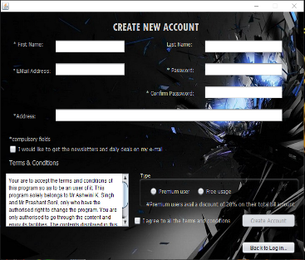

**SIGN IN:**

Through this the user can sign in to the program with a valid username and password, so as to explore the program.

**SIGN UP:**

If the user is new, he can create his new account.

**ENTER MEN SECTION:**

Through this button, one can enter the men section, which displays various kinds of products. The products shown are just a demo and programmer can add or delete the products for later usage.

**ENTER WOMEN SECTION:**

Through this button, one can enter the men section, which displays various kinds of products. The products shown are just a demo and programmer can add or delete the products for later usage.

**BILLING WINDOW:**

Through this button, one can see the items in his cart and place order by specifying the quantity required.

**ADMIN SECTION:**

Through this button, one can enter the admin section by providing suitable user id and password. This section is especially designed for the administrator for updating stock, viewing item details, registered user details and transaction details.